Contents

Social Account requirements: 1

Step to connect the Page to Instagram account: 1

Deploy the project: 1

Simple Testing: 1

Guide to prepare for the demo

# Social Account requirements:

* Facebook business account
* Facebook business page
* Instagram business account
* Connection between these accounts

# Step to connect the Page to Instagram account:

* Switch facebook accout to using Page account
* Go to Page management

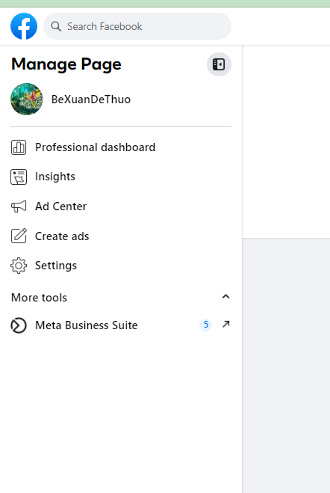

* Go to Settings > Link Accounts

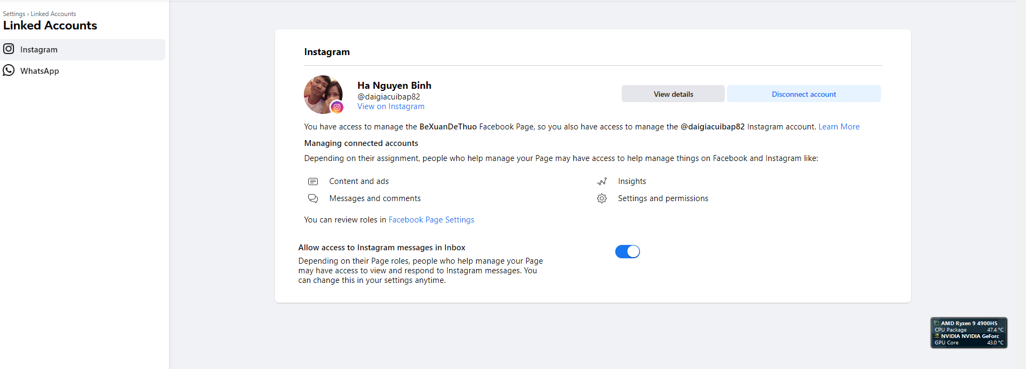

Then follow the facebook form to complete this process.

* Get facebook user id and facebook page id
  + Open this url: <https://developers.facebook.com/tools/explorer>
  + Click on Generate access token button to create new token
  + Query /me?field=name to get fbUserId
  + Query /{fbUserId}/accounts to get all accounts related to facebook accounts
  + Find the account (page) that connected to Instagram business account

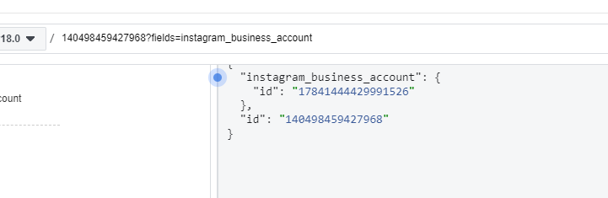

* + Use the id to query the instagram business account
* Store Instagram business account id to backend configuration file.

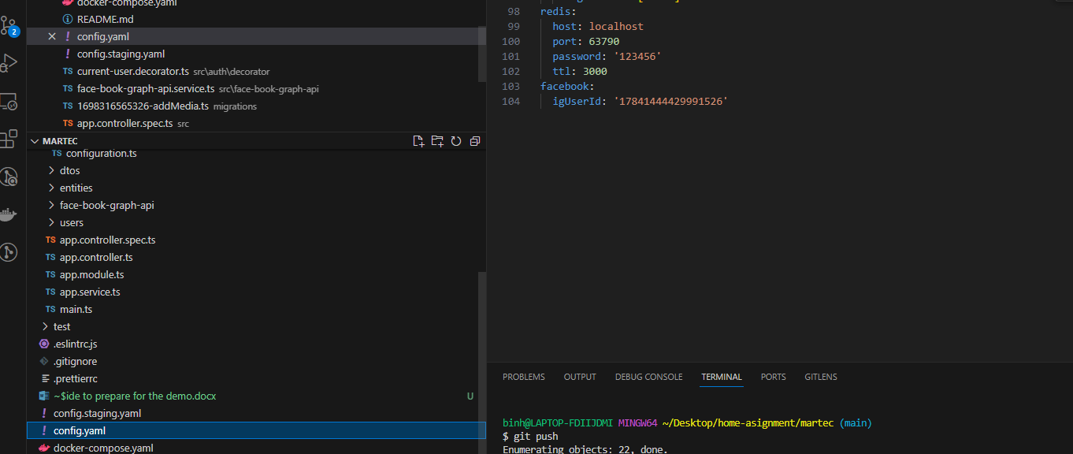

# Deploy the project:

Step to deploy the project:

* **setup the social account: please read Guide to prepare for the demo**
* **copy the igUserId (from step 1), then place it in the config.yaml file**
* **Go to martec source dir, input the command line: docker-compose up --build**
* **Go to martec-frontend source dir, input the command line: docker-compose up --build**
* **By default, the backend url is: https://localhost:3000, the front end url is: https://localhost:5000**
* **API document url: https://localhost:3000/swagger**

# Simple Testing:

checking the publis image function:

* **goto https://localhost:5000**
* **click to "Login with Facebook" button**
* **app should be redirect to dashboard page**
* **input image url to the image url text box: ex: https://scontent.fsgn13-4.fna.fbcdn.net/v/t39.30808-6/391654215_851853893105819_8743473212826596379_n.jpg?stp=dst-jpg_p720x720&_nc_cat=107&ccb=1-7&_nc_sid=5f2048&_nc_ohc=xzjJ5Rh5yC8AX_KI8IG&_nc_ht=scontent.fsgn13-4.fna&cb_e2o_trans=q&oh=00_AfDE8HIZq9UjmPwNICaaDnfKPzZs7vLgf_98gnhuKHtO5A&oe=653E5388**
* **click Go button, then go to the instagram page to check the result.**
* **by default, it should be here:** [**https://www.instagram.com/{your**](https://www.instagram.com/%7byour)**-instagrame-page}/**